Table 1.1 : 運算(operator)符號彙整表

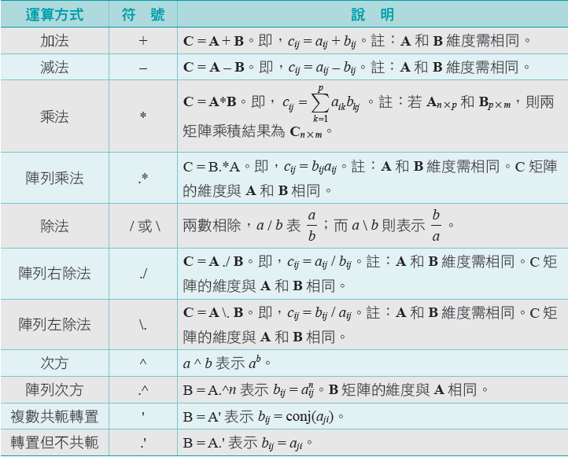

Hint:

1. Basic arithmetic expression (number or variable A,B ,C ) + operator
2. Number or variable: constant, or array (include vector, and matrix).
3. Statement Variable= arithmetic expression.

Table 2.1 : 變數名稱限制與規定

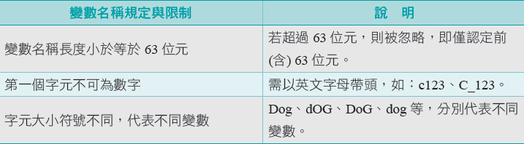

Table 2.2 : Constant symbol (Cannot be used as variable name)

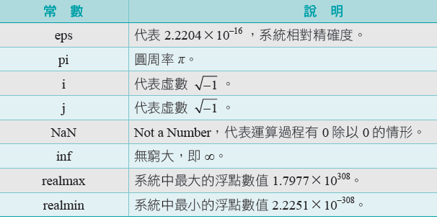

Table 2.3 (I) : Intialize row vector

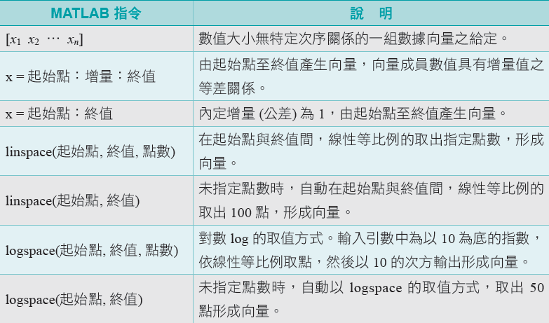

Table 2.3 (II) : Inner product & Cross product

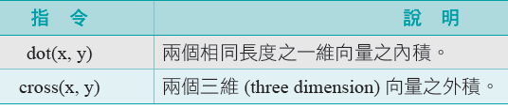

Table 2.6: (Common Input-Output functions)

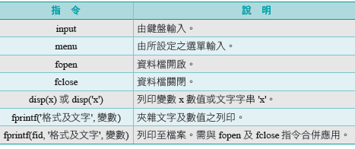

fprintf format

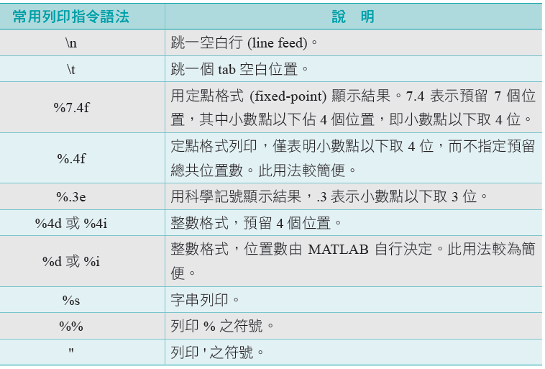

Table 4.1: (Common build-in functions (I)– Triangular functions)

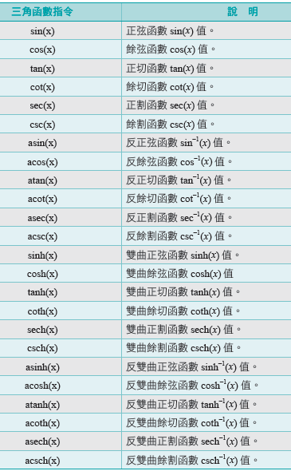

Table 4.1: (Common build-in functions (II)– Some other math. functions)

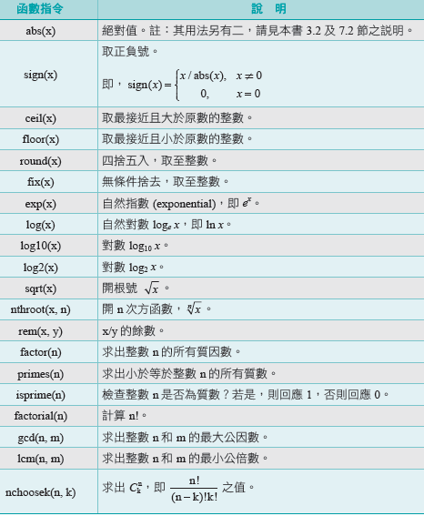

Table 4.1: (Common build-in functions (III)– Some other math. functions)

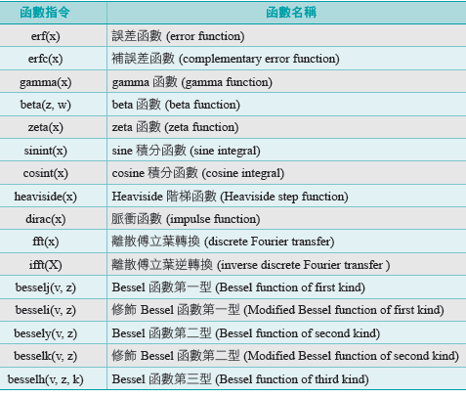

Table 5.1: Relationship operators

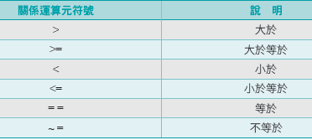

Table 5.2 Logical operators

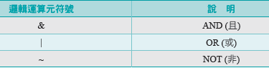

Table 5.4 Logical functions

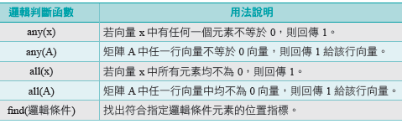

Table 5.3 in text p.116

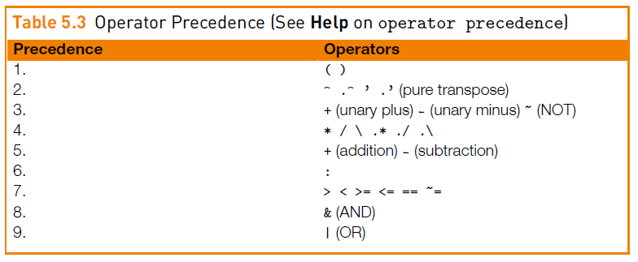

Table 6.1 (I) : Functions for matrix operation

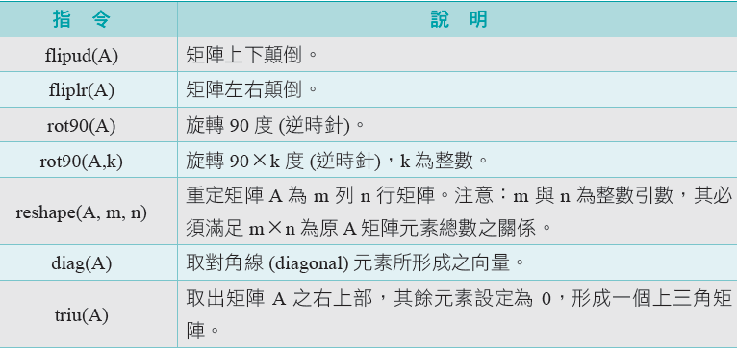

Table 6.1 (II) : Generate the special matrix

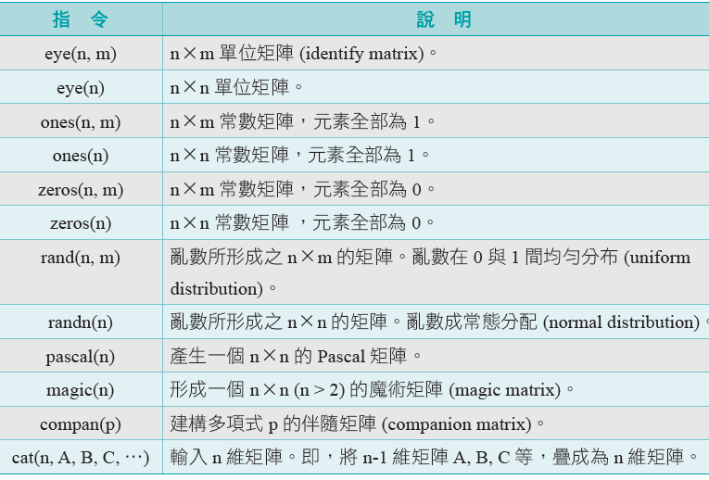

Table 6.1 (III) : Functions for matrix value

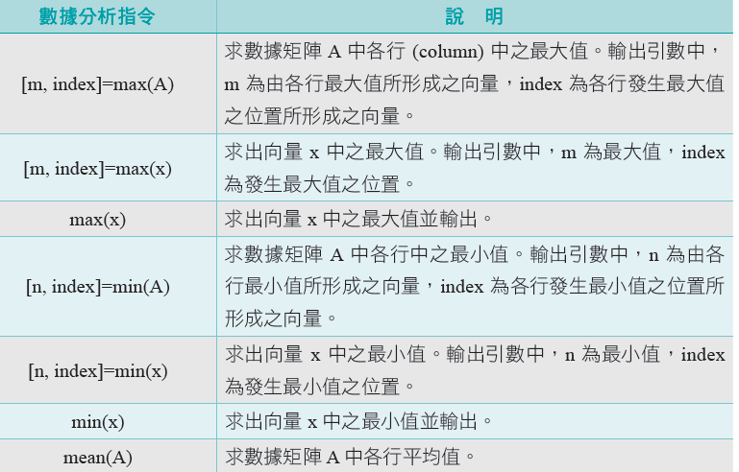

Table 6.1 (IV) : Functions for matrix value

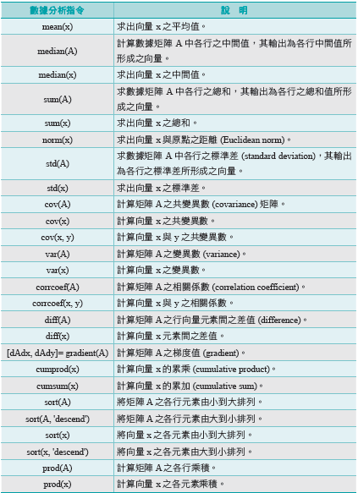

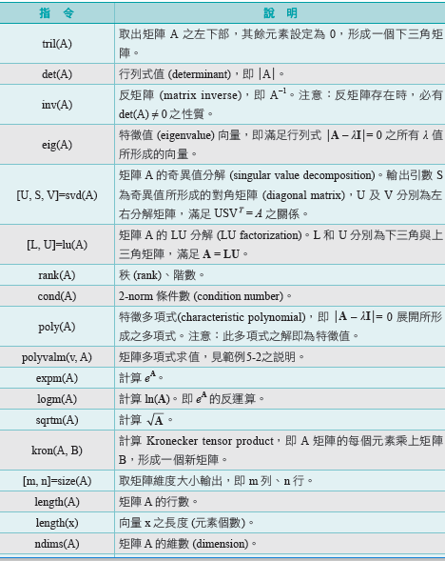Table 6.2 matrix operation

Table 7 : Function definition

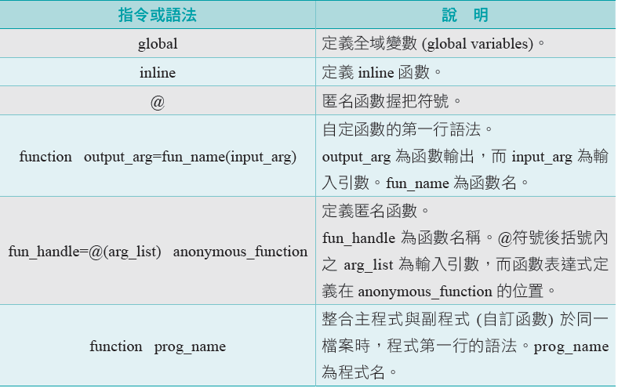

Table 8 : Loop control functions

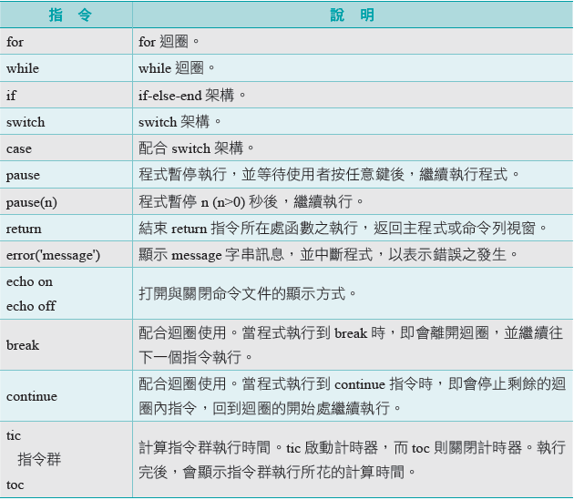

Table 9.1 : Basic 2-D Graphics

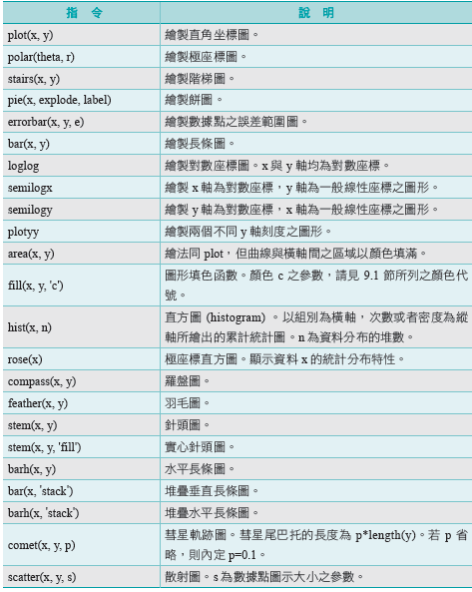

Table 9.2 : Basic 3-D Graphics

